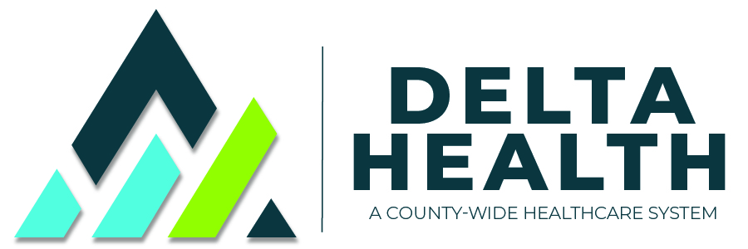

**DCMHD BOARD OF DIRECTOR’S MEETING**

**Monday, August 16, 2021**

**5:30 p.m. Classroom B / Zoom Meeting for Public**

**A G E N D A**

# I. Call to Order, *Board Chair Jean Ceriani*

**II. Agenda Changes?**

**III. Public Comment**

**IV.** **Consent Agenda,** *Board Chair Jean Ceriani*

## A. Approval of July 15, 2021 Special Board Meeting Minutes *

B. Approval of July 19, 2021 Regular Board Meeting Minutes *

C. Approval of July 30, 2021 Special Board Meeting Minutes *

D. Approval of August 11, 2021 Special Board Meeting Minutes *

**V. Financial**

A. Finance Committee Meeting Highlights, *Matt Soper*

B. July 2021 Financial Reports, *CFO Larry Vincent* *

C. Appoint Person to Prepare Budget, *Board Chair Jean Ceriani*

**VI.** **Administration**

A. COVID Update, *CCO Jody Roeber*

**VII. Medical Staff**

A. Medical Staff Credentialing, *Dr. Mixter*

B. Chief of Staff Report, *COS Dr. McCrackin*

**VIII. Other Business**

A. Further Comments, *Board Members*

# Executive Session

A. Lease or Sale of Real Property, CRS 24-4-402(4)(a), specifically 185 Stafford Ln.

B. Personnel Matters, CRS 24-6-402(4)(f), specifically Matthew M. Heyn

# Adjournment